## [VISVESVARAYA TECHNOLOGICAL UNIVERSITY](http://www.vtu.ac.in/)



#### “JNANA SANGAMA”, BELAGAVI-590018

**A Mini Project Report On**

S ***“Railway Database Management System”***

#### Submitted in the partial fulfillment of the requirement for the award of degree of

**BACHELOR OF ENGINEERING IN**

**INFORMATION SCIENCE AND ENGINEERING**

|  |  |  |
| --- | --- | --- |
|  | **Submitted By** |  |
| **JYOTSNA B** | **POOJA GUTTAL** | **SRIMA SHETTY** |
| **1VA18IS010** | **1VA18IS023** | **1VA18IS045** |
|  | **Under the Guidance of** |  |
|  | **Prof. Vivek Bongale** |  |
|  | **Assistant Professor,** |  |
|  | **Dept. of IS&E** |  |

**DEPARTMENT OF INFORMATION SCIENCE AND ENGINEERING**

## SAI VIDYA INSTITUTE OF TECHNOLOGY

**(Affiliated to Visvesvaraya Technological University, Belagavi | Recognized by Govt. of Karnataka | Approved by AICTE, New Delhi)**

#### RAJANUKUNTE, BENGALURU – 560 064

**2020-21**

SAI VIDYA INSTITUTE OF TECHNOLOGY



**Affiliated to Visvesvaraya Technological University, Belagavi | Recognized by Govt. of Karnataka | Approved by AICTE, New Delhi)**

#### Rajanukunte, Bengaluru-560 064

**DEPARTMENT OF INFORMATION SCIENCE AND ENGINEERING**

CERTIFICATE

Certified that the mini project work entitled ***“Railway Dabatase Management System”*** carried out by

Ms. JYOTSNA B (1V18IS010), Ms. POOJA GUTTAL (1VA18IS023) and Ms. SRIMA SHETTY (1VA8IS045) , bonafide students of SAI VIDYA INSTITUTE OF TECHNOLOGY, **Bengaluru, in partial fulfillment for the award of Bachelor of Engineering in Information Science & Engineering of VISHVESVARAYA TECHNOLOGICAL UNIVERSITY Belagavi during the year 2020-21. It is certified that all corrections/suggestions indicated for Internal Assessment have been incorporated in the report deposited in the departmental library. The mini project report has been approved as it satisfies the academic requirements in respect of mini project work prescribed for the said Degree.**

**--------------------------**

**Prof. Vivek Bongale**

Assistant Professor,

Dept., of IS&E

--------------------------------------- --------------------------------------

**Dr. VRINDA SHETTY Dr. H S Ramesh Babu**

Professor & HOD, Principal, SVIT

Dept., of IS&E Bengaluru

#### Name of External Examiners Signature with Date

1.

2.

# ACKNOWLEDGEMENT

The completion of Project brings with and sense of satisfaction, but it is never completed without thanking the persons who are all responsible for its successful completion. First and foremost, we wish to express our deep sincere feelings of gratitude to our Institution, **Sai Vidya Institute of Technology**, for providing us an opportunity to do our education.

We would like to thank the **Management** and **Prof. M R Holla,** Director, Sai Vidya Institute of Technology for providing the facilities.

We extend our deepest sense of sincere gratitude to **Dr. H S Ramesh Babu**, Principal, Sai Vidya Institute of Technology, Bengaluru, for having permitted us to carry out the project work on ***RAILWAY DATABASE MANAGEMENT SYSTEM*.**

We are thankful to **Prof. A M Padmareddy,** Additional Director (Student affairs), Department of Computer Science and Engineering, Sai Vidya Institute of Technology, for his constant support and motivation.

We express our heartfelt sincere gratitude to **Dr. Vrinda Shetty**, Professor and Head, Department of Information Science and Engineering, Sai Vidya Institute of Technology, Bengaluru, for her valuable suggestions and support.

We express my special in-depth, heartfelt, sincere gratitude to **Prof. Vivek Bongale,** Asst. Prof, Department of Information Science and Engineering, Sai Vidya Institute of Technology, Bengaluru for his constant support in completing the project.

Finally, we would like to thank all the Teaching, Technical faculty and supporting staff members of Department of Information Science and Engineering, Sai Vidya Institute of Technology, Bengaluru, for their support.

|  |  |
| --- | --- |
| **JYOTSNA B** | **1VA18IS010** |
| **POOJA GUTTAL** | **1VA18IS023** |
| **SRIMA SHETTY** | **1VA18IS045** |

# ABSTRACT

RAILWAY DATABASE MANAGEMENT SYSTEM, the purpose of this management system is to assist any railway business with ease of access information about their bookings when required without going through the hassle of manual bookings. Railway Database Management System gives businesses an environment where they can easily check and update the latest information about their bookings. They can manage and automatically provide the user with ticket info via email. The Railway Database Management System is aimed to provide the relevant information about the tickets and bookings of a railway database and eliminate manual counters and bookings.

# CONTENTS

### Chapters Page No

#### ACKNOWLEDGEMENT i

ABSTRACT ii

1. INTRODUCTION TO DBMS 1
2. SYSTEM SPECIFICATIONS 4
3. SYSTEM DESIGN 6
4. FUNCTIONS 9
5. MODULES OF RAILWAY DATABASE 11

MANAGEMENT SYSTEM

1. SNAPSHOTS 12
2. CONCLUSION 23
3. BIBILOGRAPHY 25

**CHAPTER 1**

**INTRODUCTION**

Railway Database is a collection of data and Management System pertaining to railways.

The railway database helps manage the booking and cancellation of tickets and to store & access those data in an easy and effective manner.

#### What is the need of Database Management System?

Database systems are basically developed for large amount of data. Here, when dealing with huge amount of data related to booking and cancellation of tickets, there are two things that require optimization: Storage of this data and retrieval of required data.

**Storage:** According to the principles of database systems, the data is stored in such a way that it acquires lot less space as the redundant data (duplicate data) has been removed before storage. Let’s take a layman example to understand this. In a banking system, suppose a customer is having two accounts, one is saving account and another is salary account. Let’s say bank stores saving account data at one place (these places are called tables we will learn them later) and salary account data at another place, in that case if the customer information such as customer name, address etc. are stored at both places then this is just a wastage of storage (redundancy/ duplication of data), to organize the data in a better way the information should be stored at one place and both the accounts should be linked to that information somehow. The same thing we achieve in our Railway DBMS.

**Fast Retrieval of data**: Along with storing the data in an optimized and systematic manner, it is also important that we retrieve the data quickly when needed. Database systems ensure that the data is retrieved as quickly as possible.

The choice of a database product is often influenced by factors such as:

* + - The computing platform (i.e., hardware, operating system)
    - The volume of data to be managed
    - The number of transactions required per second

Railway Database Management System

* + - Existing applications or interfaces that an organization may have support for heterogeneous and/or distributed computing
    - Cost
    - Vendor support

#### Design and Modeling:

The first task of a database designer is to produce a [conceptual data model](https://en.wikipedia.org/wiki/Conceptual_data_model) that reflects the structure of the information to be held in the database. A common approach to this is to develop an entity-relationship model, often with the aid of drawing tools. Another popular approach is the [Unified Modeling Language.](https://en.wikipedia.org/wiki/Unified_Modeling_Language) A successful data model will accurately reflect the possible state of the external world being modeled: for example, if people can have more than one phone number, it will allow this information to be captured.

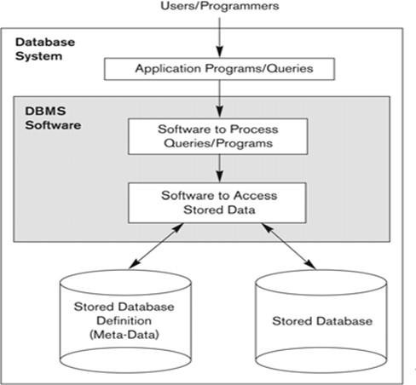

**Figure 1.1: Simplified database system environment**

Railway Database Management System

#### Problem Statement

Existing systems for Railway Database Management are very inefficient and mostly involve a lot of manual work to be done by the manager of the system. With this project, we want to automate as many tasks as possible using the available technology and the internet.

#### Objective

The main objective of this project is to determine how an interactive Railway Database management system helps in the smooth functioning of a Railway compared to traditional Railway database management, by digitizing all the records and transacting everything on a Computer rather than on paper. This project is a two-tier architecture application

**CHAPTER 2**

**SYSTEM SPECIFICATIONS**

#### 2.1 SOFTWARE REQUIREMENTS

Programming language : HTML, Xampp

Operating system : ANY OS (Recommended**:** Windows8,

Windows Vista, Windows XP) Application required : Standalone desktop application & Xampp Coding language : PHP

#### 2.2 HARDWARE REQUIREMENTS

CPU : Pentium IV 2.4 GHz or above Memory (Primary) : 512 MB, 1 GB or above

Hard Disk : 40 GB, 80GB, 160GB or above

Monitor : 15 VGA color

#### 2.3 SUBLIME TEXT 3

**Sublime Text 3 (ST3)** is a lightweight, cross-platform code editor known for its speed, ease of use, and strong community support. It's an incredible editor right out of the box, but the real power comes from the ability to enhance its functionality using Package Control and creating custom settings.

#### 2.4 XAMPP

**XAMPP** is a free and open source cross-platform web server solution stack package developed by Apache Friends, consisting mainly of the Apache HTTP Server, MariaDB database, and interpreters for scripts written in the PHP and Perl programming languages. XAMPP stands for Cross-Platform (X), Apache (A), MariaDB (M), PHP (P) and Perl (P). It is a simple, lightweight Apache distribution that makes it extremely easy for developers to create a local web server for testing and deployment purposes. Everything needed to set up a web server – server application (Apache), database (MariaDB), and scripting language (PHP) – is included in an extractable file.

4

Railway Database Management System System Specification

#### 2.5 BROWSER

Google Chrome is preferably used to run the web server locally. "Localhost" refers to the local computer that a program is running on. Localhost is used in Web scripting languages like PHP, for defining Apache server the code should run from or where the online book store database is located.

5

## CHAPTER 3

**SYSTEM DESIGN**

This chapter of the report describes the structure of the project, followed by Entity Relationship Diagram, Schema Diagram and the table structures.

#### ER Diagram with relationships and cardinality ratio

An entity relationship model*,* also called an entity-relationship (ER) diagram*,* is a graphical representation of entities and their relationships to each other, typically used in computing in regard to the organization of [data](http://www.webopedia.com/TERM/D/data.html) within [databases](http://www.webopedia.com/TERM/D/database.html) or information systems. An entity is a piece of data-an [object](http://www.webopedia.com/TERM/O/object.html) or concept about which data is stored.

The cardinalit*y* or fundamental principle of one data aspect with respect to another is a critical feature. The relationship of one to the other must be precise and exact between each other in order to explain how each aspect links together. In simple words Cardinality is a way to define the relationship between two entities.

The following are the notations of the ER diagram:

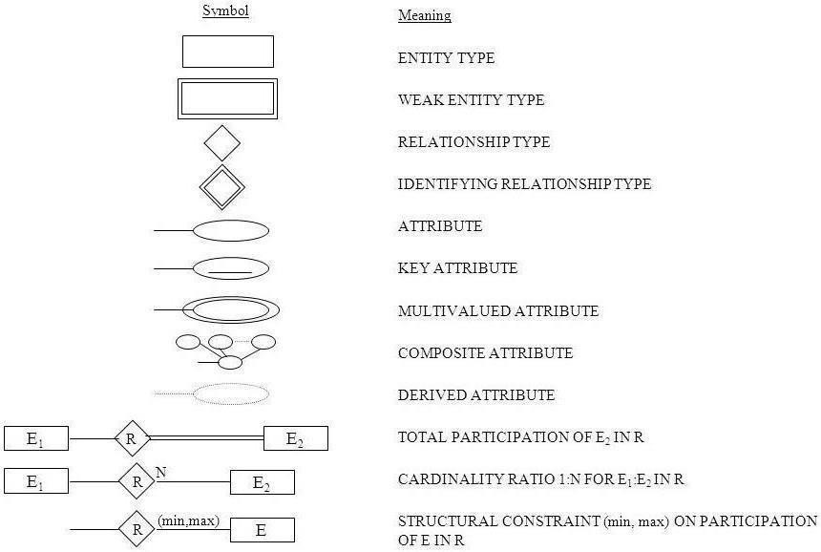

**Fig 3.1: Notations for ER Diagrams**

6

Railway Database Management System Design

The ER diagram below shows the relationship between the many tables that exist in the database for the functioning of Railway Database Management System.

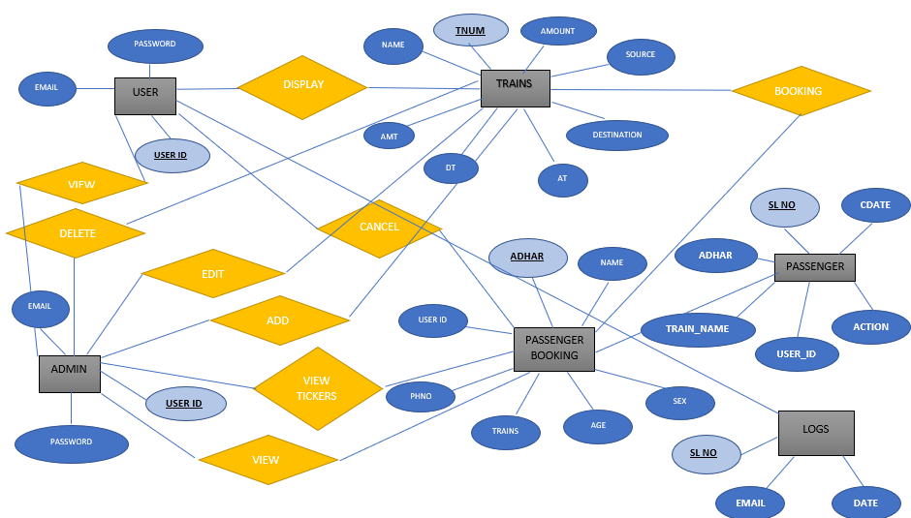

**Fig 3.2: ER Diagram Railway Database Management System**

#### Schema Diagram

In any data model it is important to distinguish between the description of the database and the database itself. The description of a database is called the database schema, which is specified during database design and is not expected to change frequently.

A displayed schema is called a schema diagram. A schema diagram displays only some aspects of a schema, such as the names of record types and data items, and some types of constraints.

7

Railway Database Management System Design

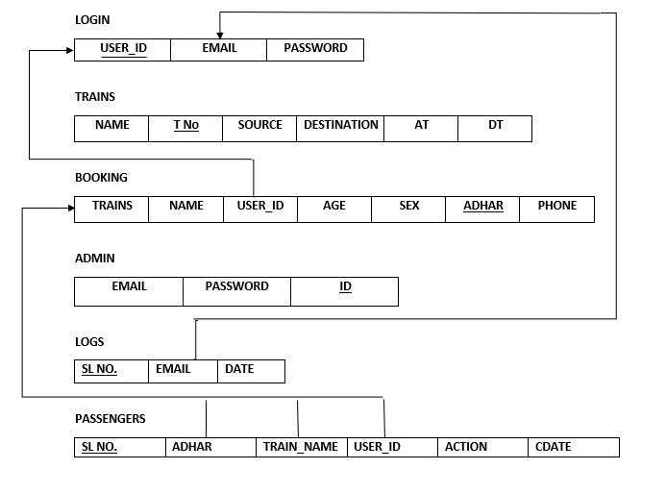

**Fig 3.3: Schema Diagram**

8

**CHAPTER 4**

**FUNCTIONS**

This chapter of the report describes the Functions, packages and modules used in the project:

**4.1 LIBRARIES AND FRAMEWORKS**

**HTML**

**HTML is** a general-purpose computer-programming language that is concurrent, text- based, web- oriented, and specifically designed to have as few implementation dependencies as possible

#### CSS

Cascading style sheets is a design-oriented module which helps in the designing of the webpage according to our perspective.

#### PHP

**PHP** is a recursive acronym for "**PHP**: Hypertext Preprocessor". **PHP** is a server-side scripting language that is embedded in HTML. It is used to manage dynamic content, databases, session tracking, even build entire e-commerce sites.

**XAMPP**

**XAMPP** is a free and open-source cross-platform web server solution stack package consisting mainly of the Apache HTTP Server, MariaDB database, and interpreters for scripts written in the PHP and Perl programming languages. It is a simple, lightweight Apache distribution that makes it extremely easy for developers to create a local web server for testing and deployment purposes. Everything needed to set up a web server – server application (Apache), database (MariaDB), and scripting language (PHP) – is included in an extractable file.

#### Integrating the Website and the Database

Customers ordering from an e-commerce website need to be able to get information purchase, and submit payment information. Vendors need to be able to track customer inquiries and preferences and process their orders. So a well-organized database is essential for the development and maintenance of an e-commerce site.

9

Railway Database Management System Design

In a static Web page, content is determined at the time when the page is created. As users access a static page, the page always displays the same information. Example of a static Web page is the page displaying company information. In a dynamic Web page, content varies based on user input and data received from external sources. We use the term “data-based Web pages” to refer to dynamic Web pages deriving some or all of their content from data files or databases.

A data-based Web page is requested when a user clicks a hyperlink or the submit button on a Web page form. If the request comes from clicking a hyperlink, the link specifies either a Web server program or a Web page that calls a Web server program.

In some cases, the program performs a static query, such as “Display all items from

the Inventory”. Although this query requires no user input, the results vary depending on when the query is made. If the request is generated when the user clicks a form’s submit button, instead of a hyperlink,

The Web server program typically uses the form inputs to create a query. For example, the user might select five books to be purchased and then submit the input to the Web server program. The Web server program then services the order, generating a dynamic Web page response to confirm the transaction. In either case, the Web server is responsible for formatting the query results by adding HTML tags.

10

## CHAPTER 5

**MODULES IN RAILWAY DATABASE MANAGEMENT SYSTEM**

Railway Database Management System is to provide information about the bookings of a railway Database to the user/admin of the railway Database to be better organized. There are four main modules in this system:

#### Users

**Ticket Database Admin Book/Cancel tickets**

**User:**

The users have to log in to the system and can then view all the booking options

stored in the railway Database with the availability of tickets. The user can access all of the application and perform his desired activities which might in turn affect the database.

#### Ticket Database:

All the tickets are available in the database. A user can access all the data about a ticket and perform various operations such as book or cancel a ticket from the database. A ticket will have the attributes of name, departure date, age, destination, coach class. The database automatically retrieves the train ticket information from the database. The admin can book as many tickets as per the user’s requirement.

#### Admin:

In this section of the application the admin has the overall control of the booking database and can perform any action as required.

#### Book/Cancel tickets:

This section of the application lets the admin to manipulate the ticket or the booking details with either inserting or deleting the fields.

11

## CHAPTER 6

#### 1. USER LOGIN

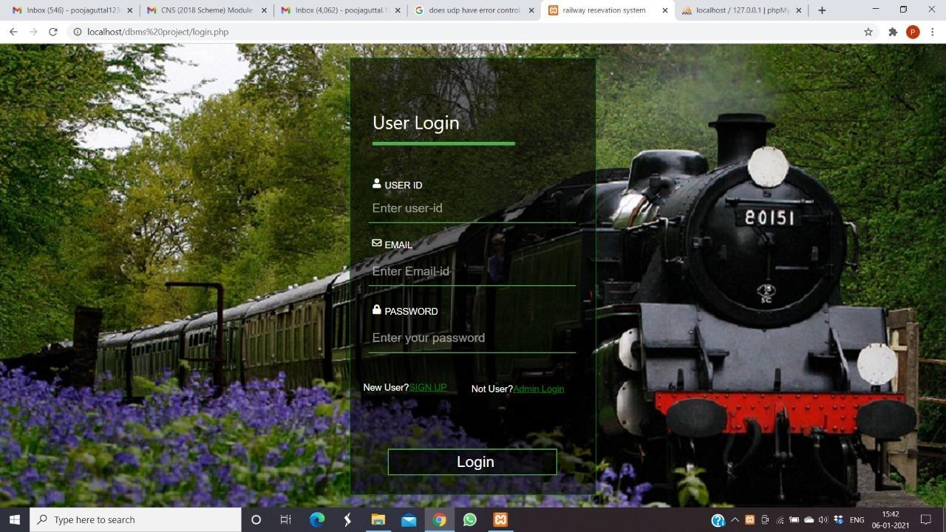

**2.USER REGISTER**

**SNAPSHOTS**

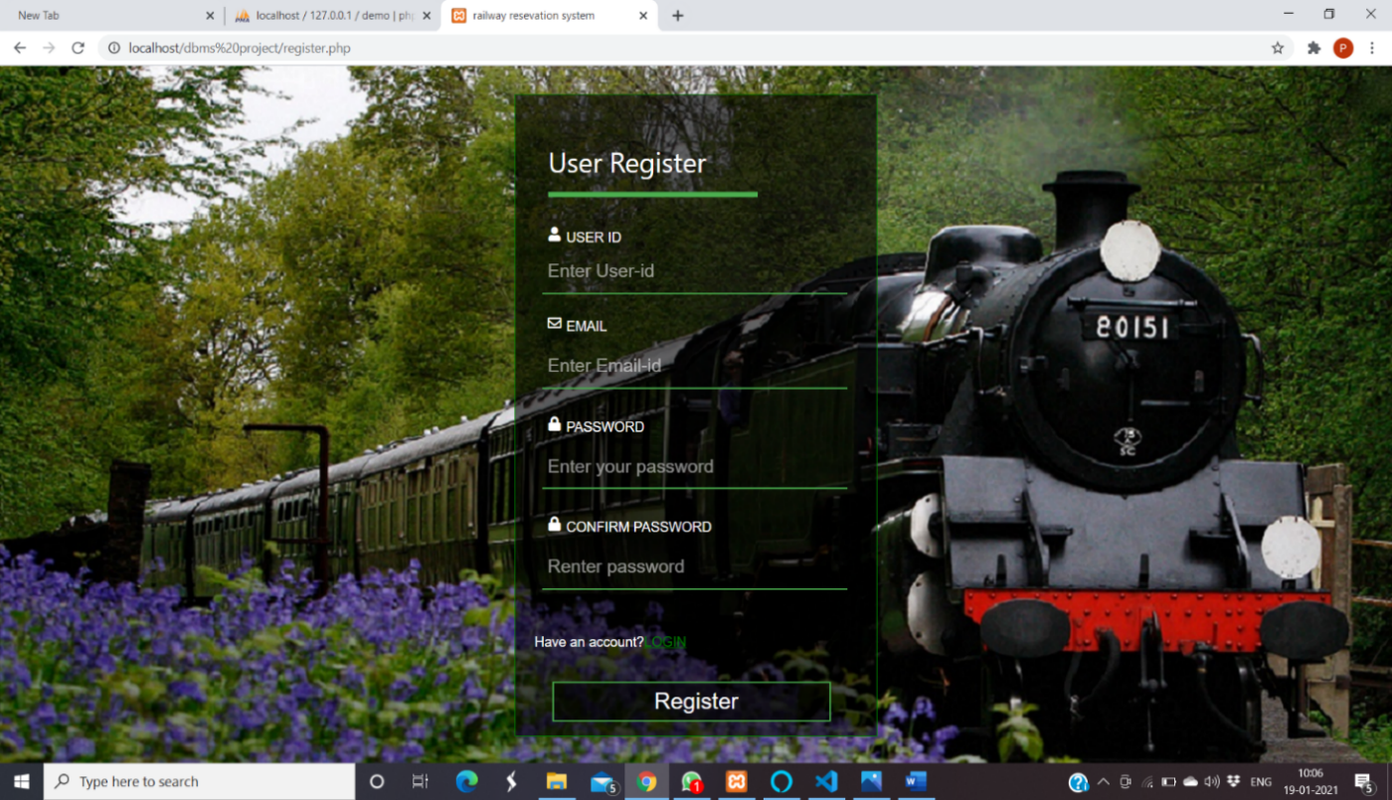

12

Railway Database Management System Snapshots

#### 3. USER NAVIGATION

#### 

#### 4. TRAIN DISPLAY

#### 

13

Railway Database Management System Snapshots

#### 5. TRAIN BOOKINGS

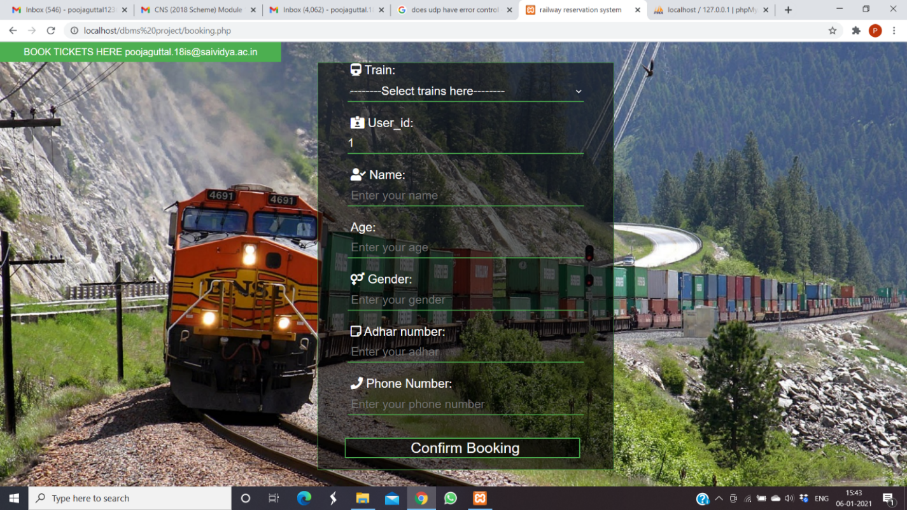

1. **VIEW TICKETS**

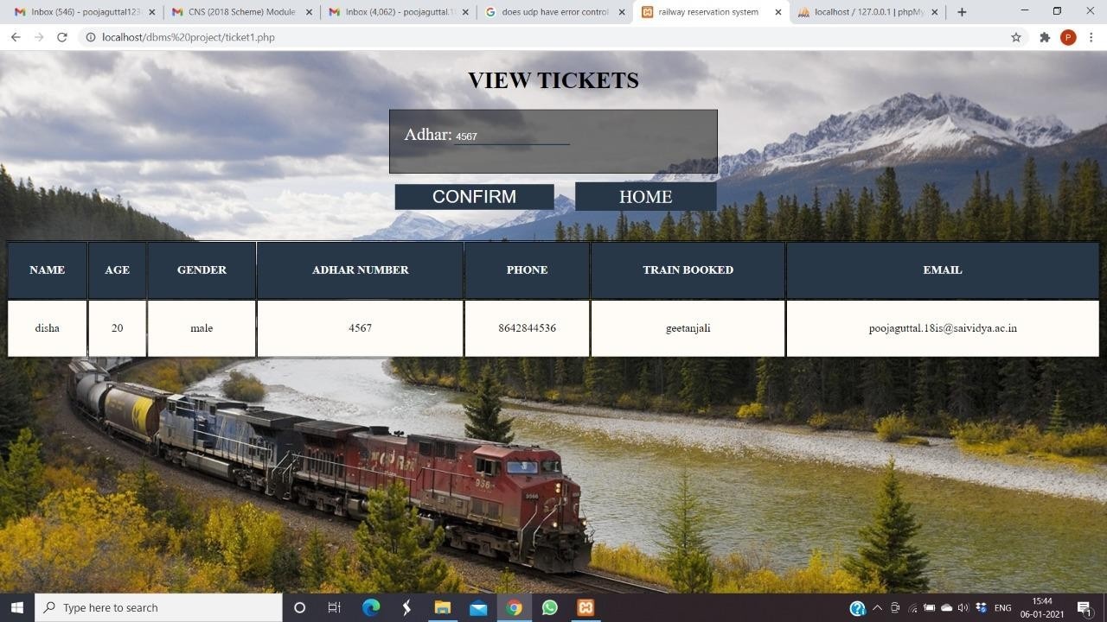

14

Railway Database Management System Snapshots

**7.CANCEL TICKET**

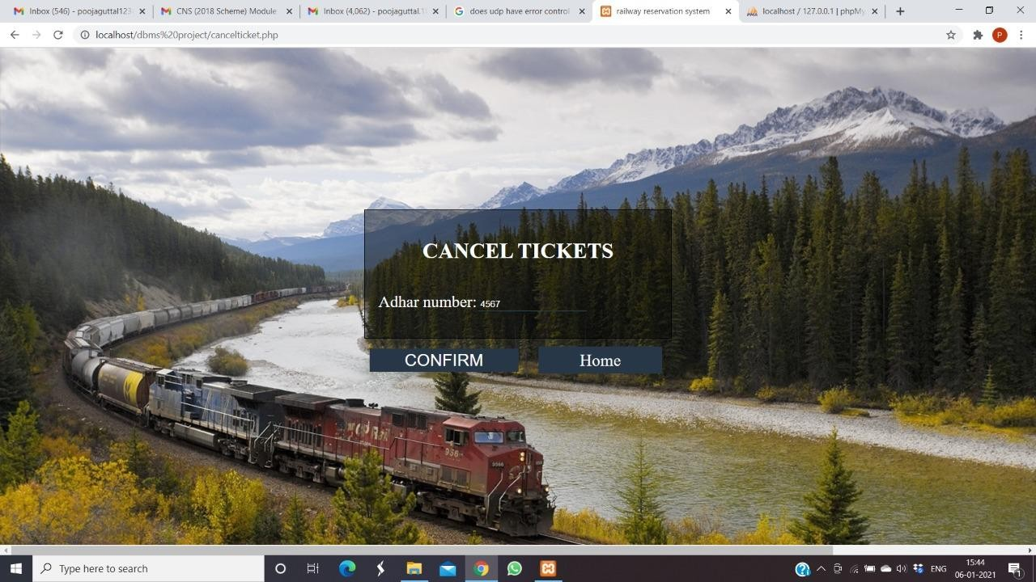

**8.ADMIN LOGIN**

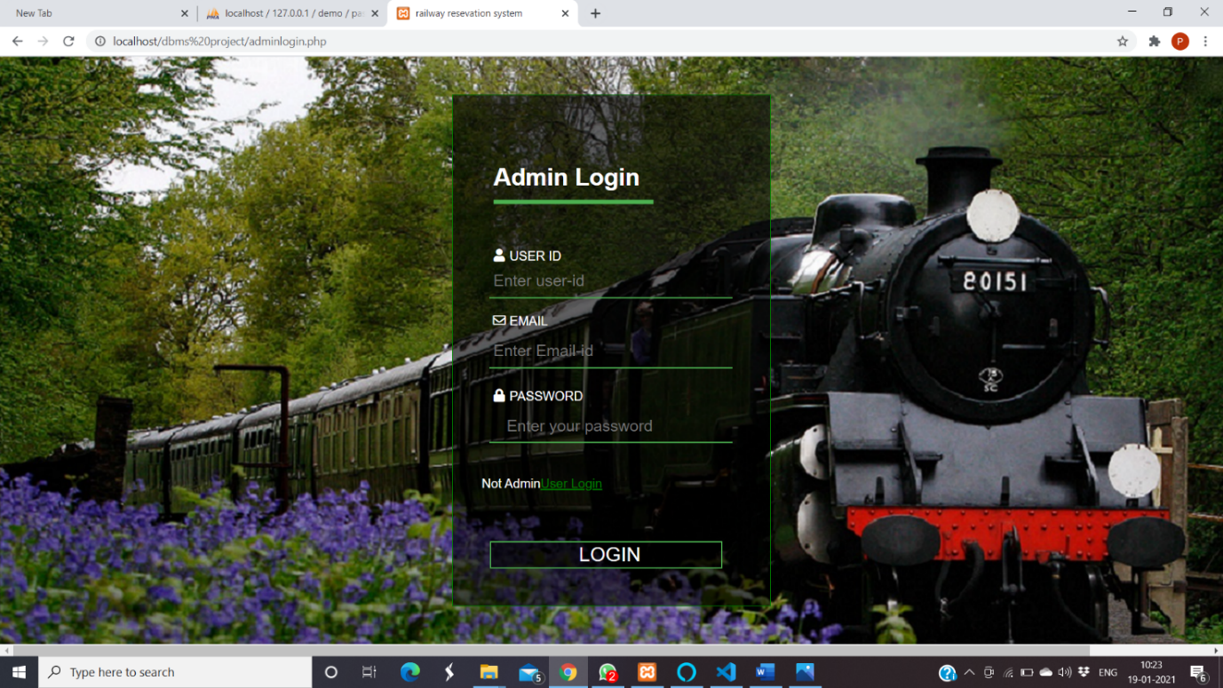

15

Railway Database Management System Snapshots

**9.ADMIN NAVIGATION**

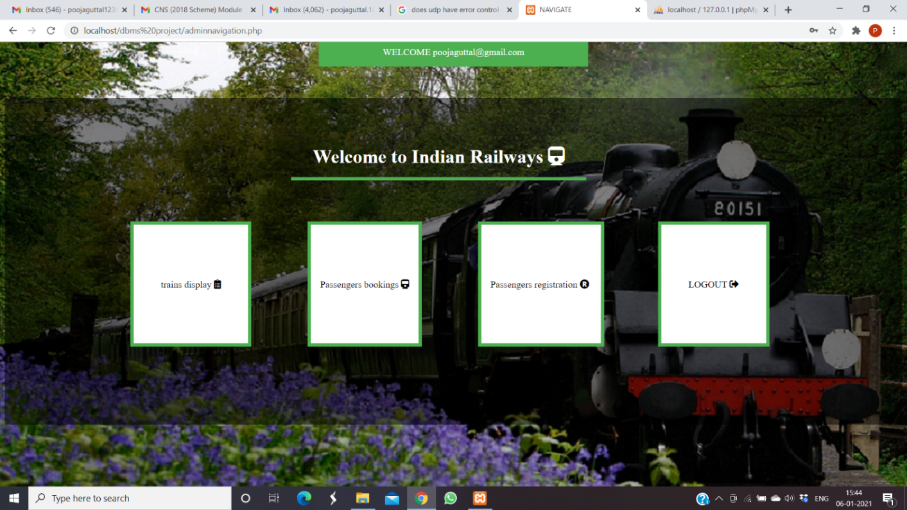

**10. ADMIN DISPLAY**

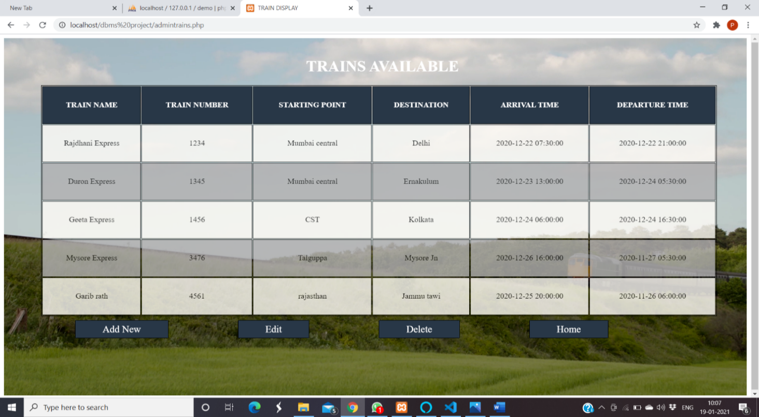

16

Railway Database Management System Snapshots

**11. ADD TRAIN**

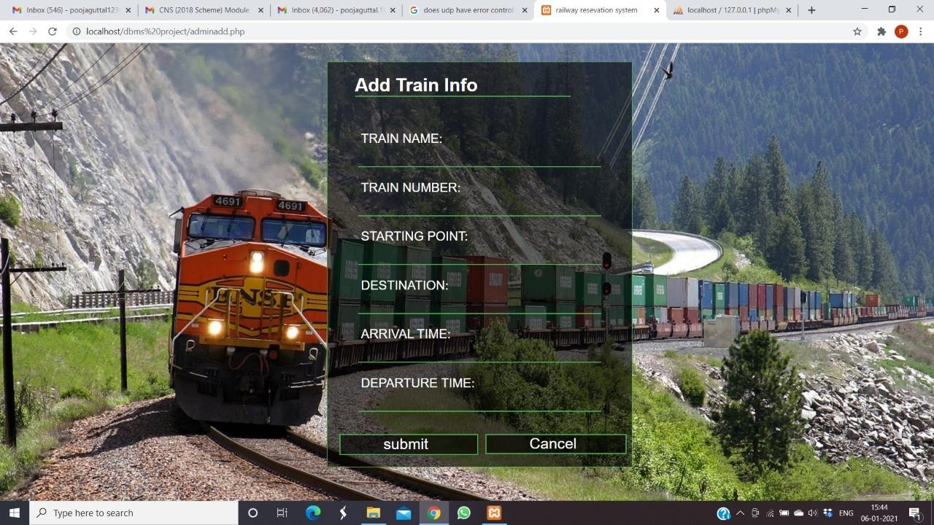

#### 12. EDIT TRAIN INFORMATION

#### 

17

Railway Database Management System Snapshots

**13.DELETE TRAIN**

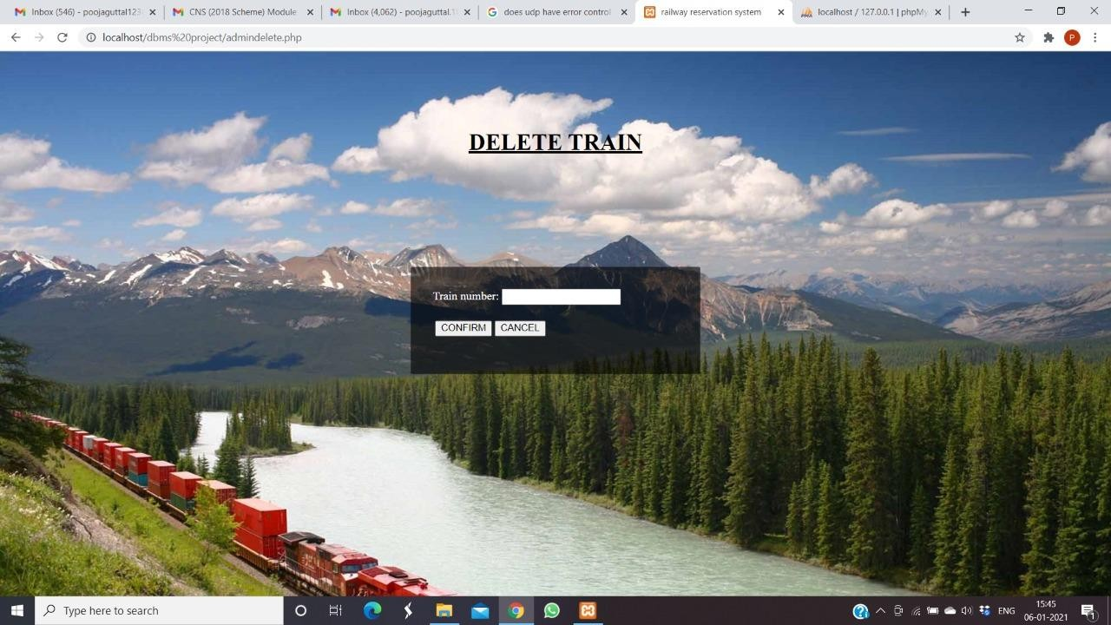

**14**. **PASSENGER REGISTER**

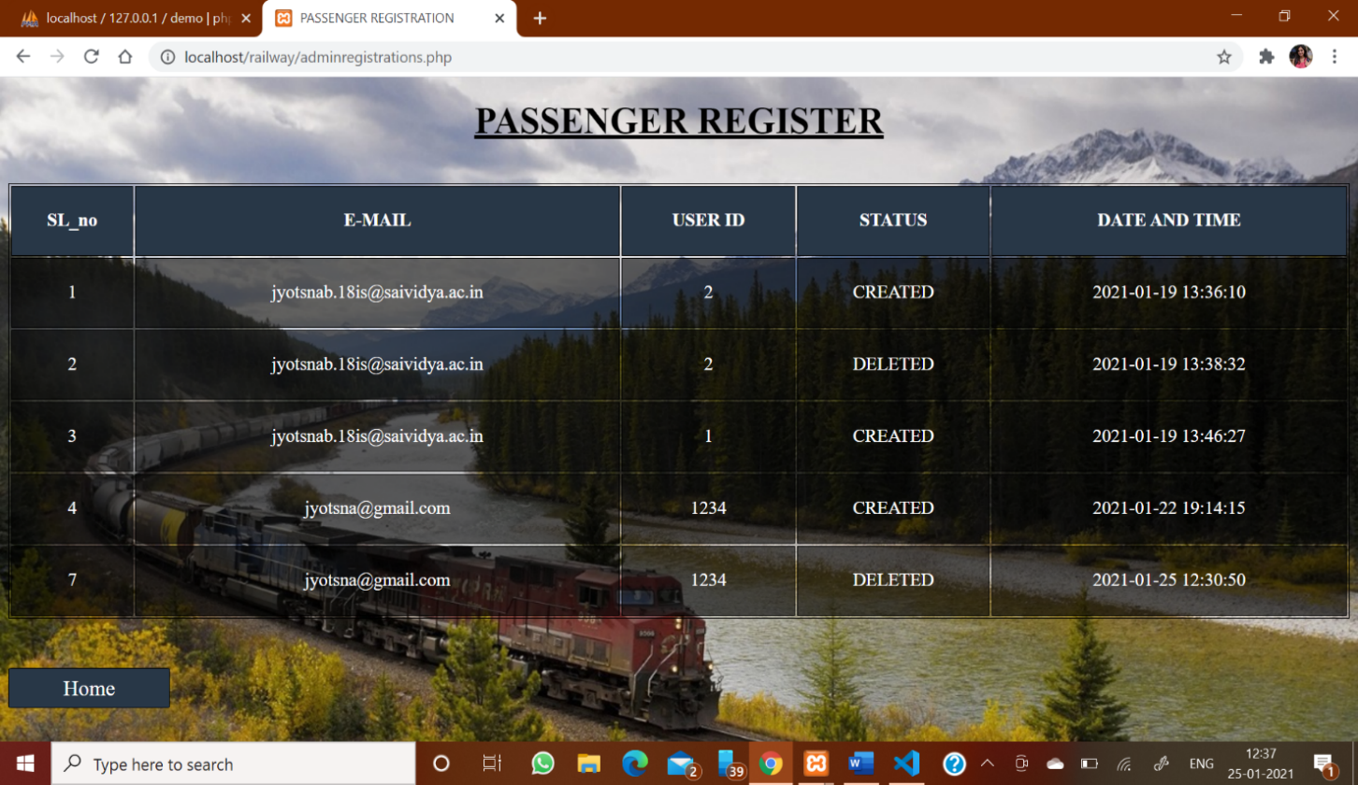

18

Railway Database Management System Snapshots

**15. PASSENGERS BOOKING**

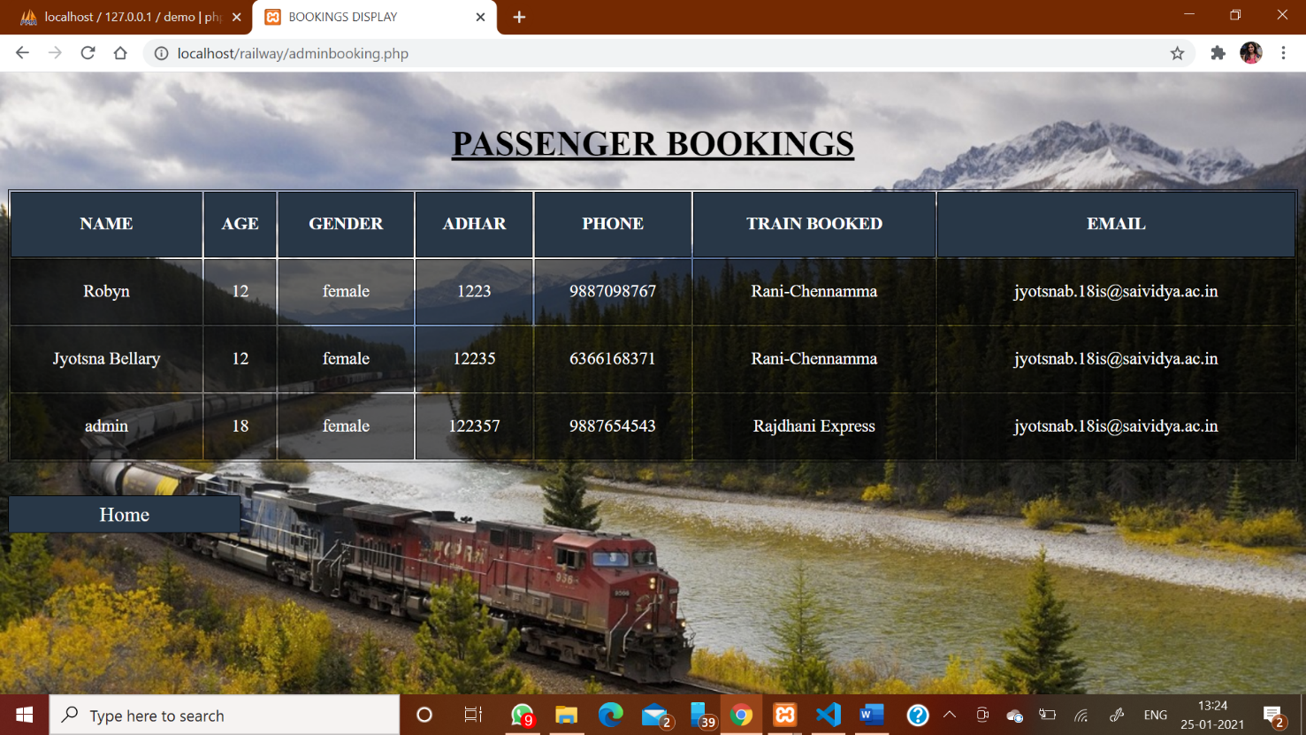

DATABASE SNAPSHOTS

**1.LOGIN TABLE**

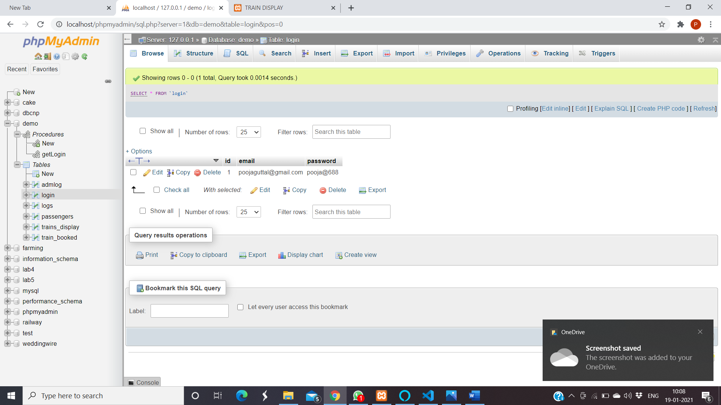

19

Railway Database Management System Snapshots

**2.TRAIN TABLE**

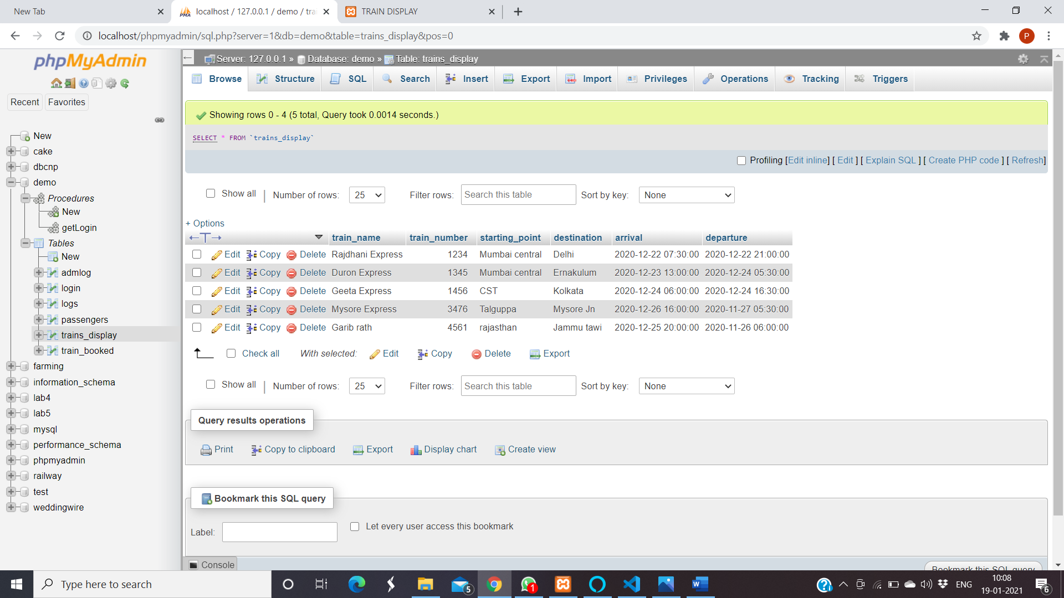

**3. TRAIN BOOKED**

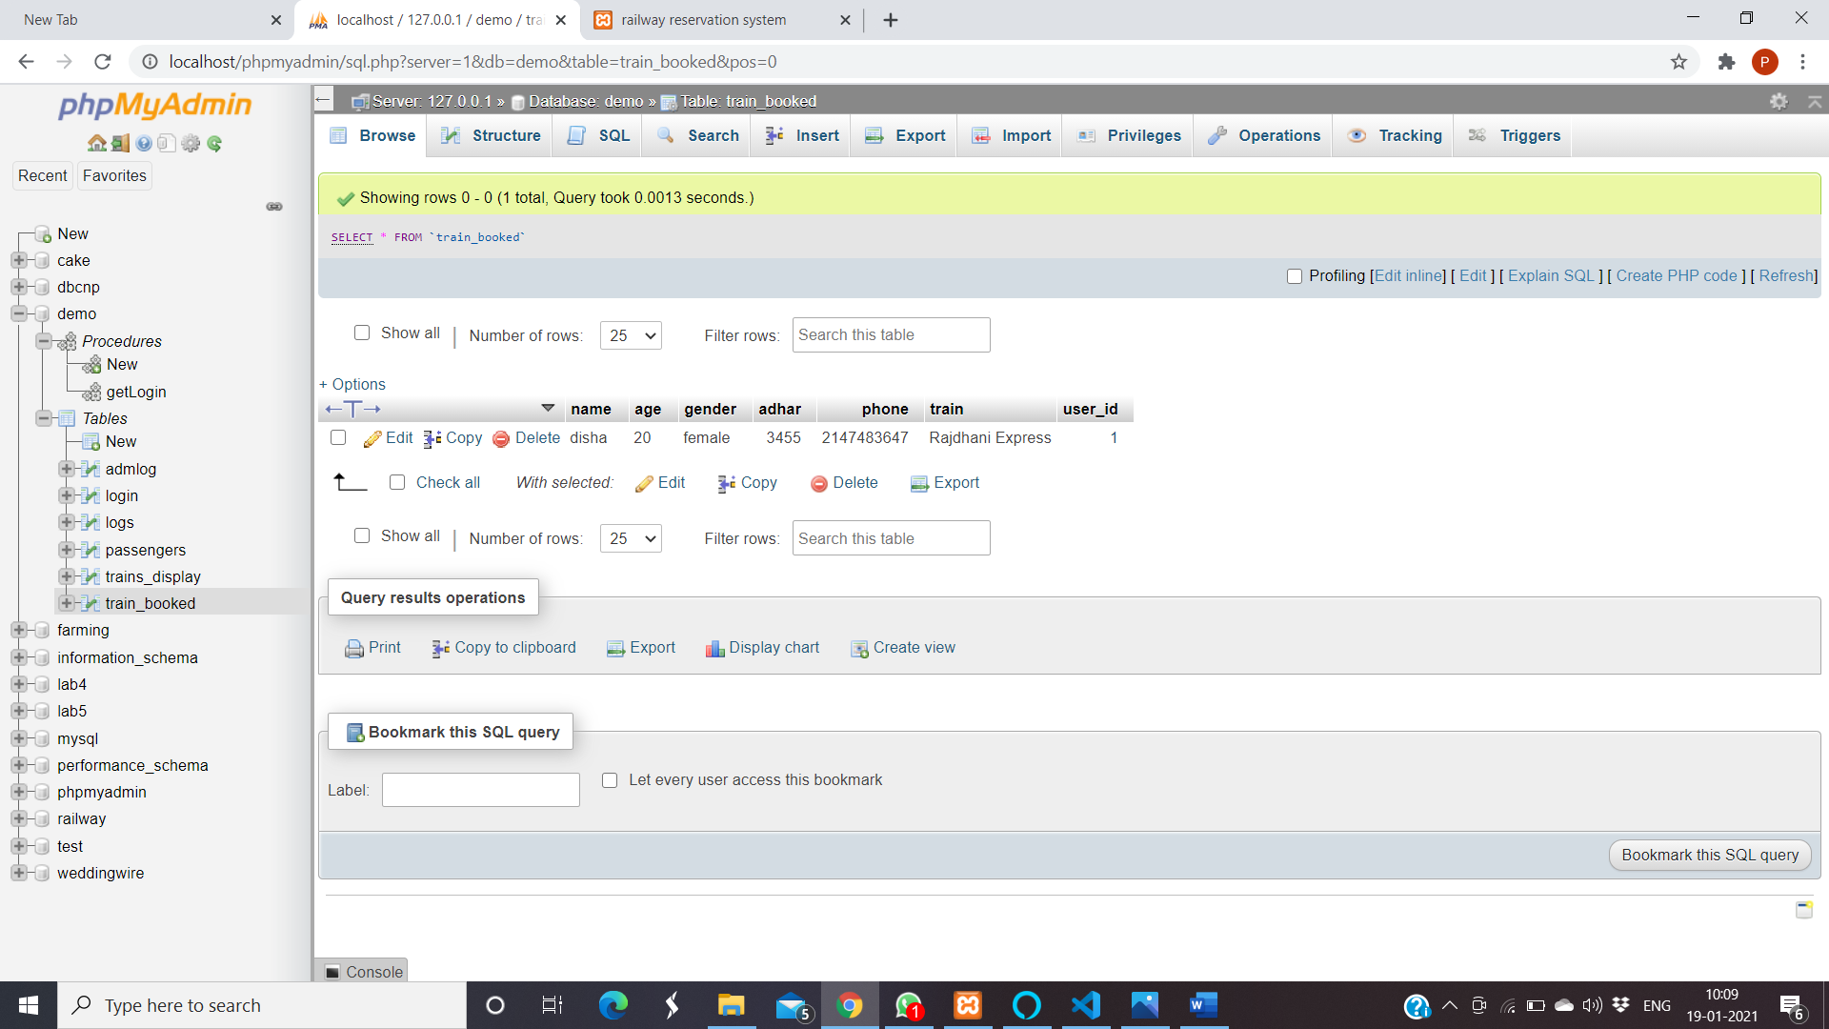

20

Railway Database Management System Snapshots

**4.ADMIN TABLE**

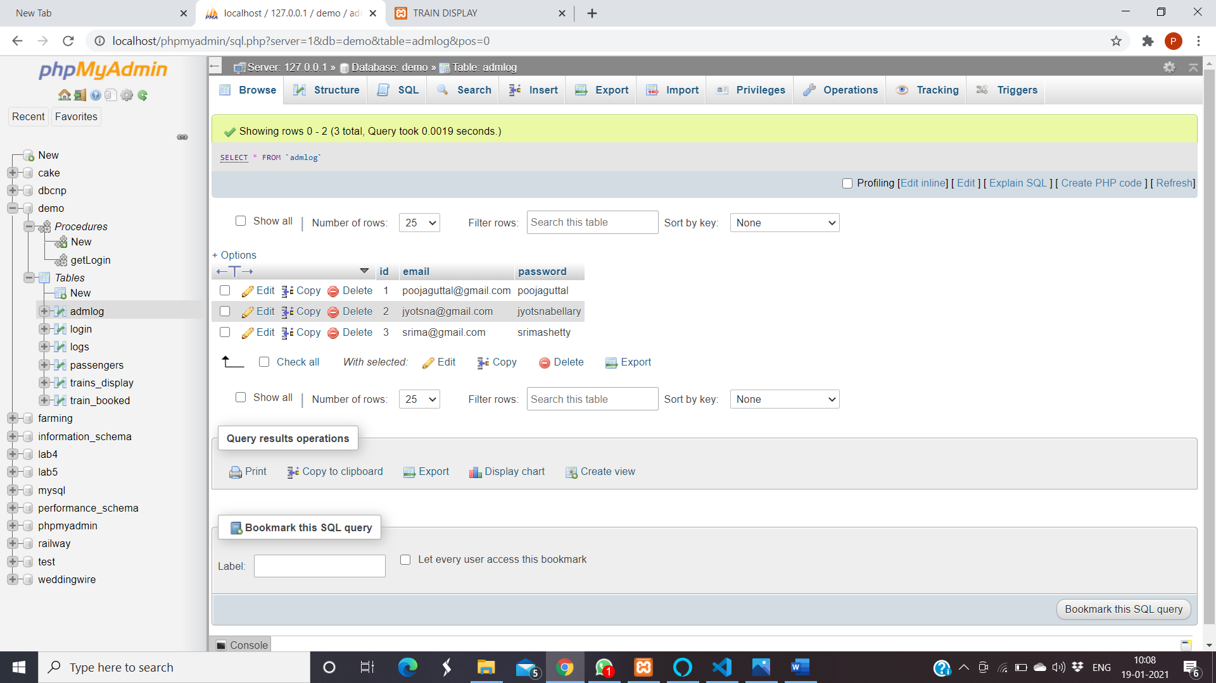

**5.LOGS TABLE (TRIGGER APPLIED)**

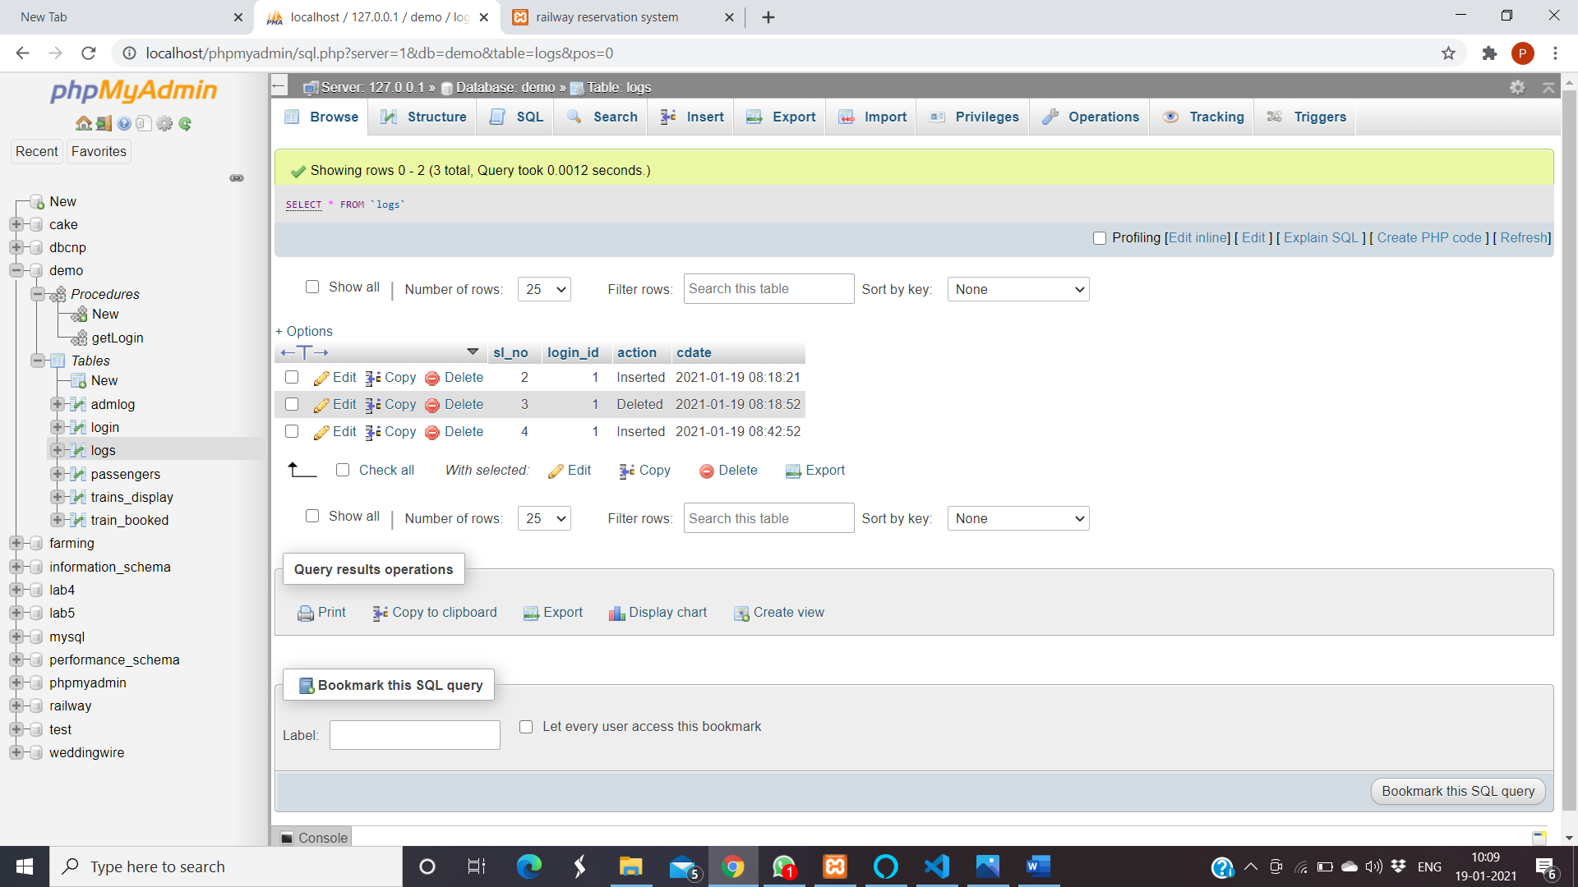

21

Railway Database Management System Snapshots

6.**PASSENGERS TABLE (TRIGGERS APPLIED)**

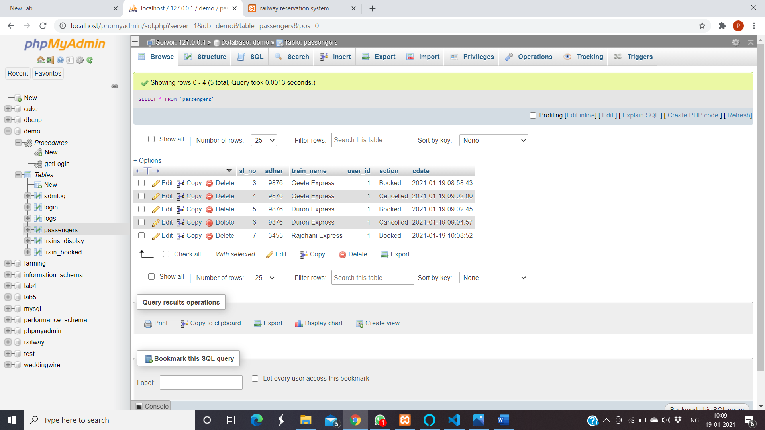

**7.STORED PROCEDURE**

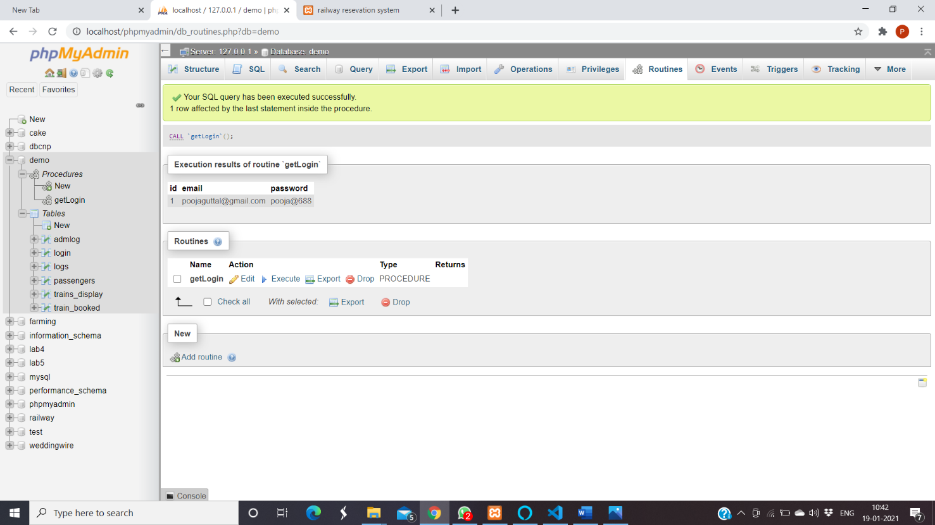

22

**CHAPTER 7**

**CONCLUSION**

The railway database management system provides better functionality for a booking system to be more efficient and reduce manual paperwork in order to automate all possible tasks. For implementing this system, HTML, CSS, PhP and Xampp are used. The system comprises of features like, management of users, management of booking, automated ticket generation and booking or cancelling of tickets.

#### SCOPE OF ENHANCEMENT

There are also few features which can be integrated with the system to make it more flexible.

Below list shows the future points to be considered:

* + Utilize multithreading to manage resources better.
  + Use hashing algorithms for storing passwords and avoid plaintext passwords.
  + Implement the update feature with hardware integration in the booking system.
  + Port the program to other popular operating systems.
  + Implement feature to book multiple seats seats at once.
  + Add a payment portal

23

**BIBLIOGRAPHY**

#### BOOK REFERENCE

[1] Database System Models, Languages.

#### WEBSITES

1. [www.stackoverflow.com](http://www.stackoverflow.com/)
2. [www.youtube.com](http://www.youtube.com/)
3. [www.google.com](http://www.google.com/)
4. [www.w3schools.com](http://www.w3schools.com/)

[5] [www.coursera.com](http://www.coursera.com)

24

Dept. of ISE,SVIT

2020-21